

**COURSE EXEMPTION MANAGEMENT SYSTEM**

**STUDENTS NO: 82722**

**82028**

An Information Systems Project Proposal Submitted to the Faculty of Information Technology in partial fulfillment of the requirements for the award of a Diploma in Business Information Technology

Date of Submission: February 2014

# DECLARATION

We declare that this project has not been submitted to any other University for the award of a

Diploma in Business Information Technology.

Student 082722:

Sign: ________________________ Date: ________________________

Student 082028:

Sign: ________________________ Date: ________________________

Supervisor’s Signature:

Sign: ________________________ Date: ________________________

# Abstract

The process of applying for an exempt course in Strathmore University is in need of change as it is now outdated and backward. We noticed this as my partner and I were applying for exemptions in degree courses we would like to join and we were astonished that we were required to fill an application form as well as a registration form which we had already filled when we first applied when joining the University. The current method of applying for a course exemption is tedious and requires quite a substantial amount of time to process as there is a lot of paperwork involved. There is need for change as the current trend of computerizing most processes is taking over and if this change is not soon effected, we would soon be left in the dust by competitors operating in the same field.

We have therefore seen that the best method to remedy this is by developing a simple system that will work with the current systems at Strathmore. Some universities such as Kyoto in Japan and Mohawk college in Canada, have already computerized there systems and students can apply online for exemption courses. Since system is currently working well in most of the universities worldwide we therefore believe that it is possible to implement in the institution. We noted that in most of the universities, one would simply be required to fill a form generated online in a specific portal which will then send the information back to the administrators for evaluation. The system will then notify the student whether his/her application was accepted or denied from the feedback given by the administrator. This should all happen without requiring one to go to the faculty and filling tedious forms unless he/she needs more information or inquiries.

We found that the best way of solving the problem was by generating the required forms online via the University’s existing AMS system where the student(s) will fill them at their own convenience. We also found that this is was the best way to solve the problem as the AMS system is available to all Strathmore University students and is a very secure platform. It is also accessible from any computer at any place in the world, therefore making it very convenient for the students.

We found that the best methodology in creating this system will be waterfall approach, it require deep analysis before proceeding to the next stage.

# TABLE OF CONTENTS

Contents

DECLARATION I

Abstract II

TABLE OF CONTENTS III

**CHAPTER 1: INTRODUCTION** 1

1.1 Background 1

1.2 Problem Statement 2

1.3 Aim 2

1.4 Specific Objectives 2

1.5 Justification 2

1.6 Scope Limitation 3

**CHAPTER 2: LITERATURE REVIEW** 4

2.1 Introduction 4

2.2 Existing Universities Currently Using a Manual System 4

2.2.1 Mohawk College, Canada 4

2.2.2 Ryerson University 5

2.2.3 Kyoto University, Japan 5

2.2.4 Carnegie Mellon University/Heinz College Pittsburgh U.S.A 6

**CHAPTER 3: METHODOLOGY** 7

3.1 Introduction 7

3.2 Analysis 8

3.2.1 Functional requirements 8

3.2.2. Non Functional requirements 8

3.2.3. Narrative 9

3.3 Design 10

3.4 System Development Tools And Techniques 12

3.5 Deliverables 12

3.6 References 13

References 13

LIST OF FIGURES

Figure 3.1 Waterfall Methodology…………………………………………………………………………7

Figure 3.2 Use Case ………………………………………………………………………………………..8

Figure 3.3 Data Flow 9

Figure3.4 Entity Relationship…………….………..……………………………………………………...10

# **CHAPTER 1: INTRODUCTION**

# 1.1 Background

Institutions of higher learning around the country are rapidly embracing the use of ICT to achieve operation excellence in recent times. Strathmore University being one of these institutions has been growing rapidly over the years, new technologies have been implemented in most of the areas such as the university’s library system, academic management system, Finance management system, Leave systems among many others. These systems are constantly being improved as the university expands. One of the systems that has seen a great change since its introduction is the academic management system, which during its introduction was not used by all courses in the university unlike today when it’s being used by all courses in the institution. .

Strathmore University is one of the few universities in the country that has been able to automate most of its systems, especially registration of university members such as students and lecturers. The university academic management system, is one of the best systems, containing all information concerning a particular student, it is able to analyze student’s records and give accurate and well-structured information about his or her performance and qualification. Including financial details.

Unfortunately not all the processes have been automated, Students undertaking diploma courses are always required to fill application and registration forms when applying for undergraduate courses in the university. We found this to be rather peculiar bearing in mind that most of this students filled the same forms when joining the university. We believe that this process should be automated, since all details of the student qualification to the degree courses is already contained in the universities database.

# 1.2 Problem Statement

What we are mainly concerned with is the application process for exempt courses by diploma students. It was rather amusing that these students had to fill forms when applying for exempt courses yet the same information was inquired when they joined the institution. The process ought to be simple and efficient.

Students applying for these exempt courses should be able to do it online, whereby they can just login to the AMS module and fill an online form. When applying for these courses, the system should be able to check the grades of the student and see whether, he/she is eligible and if so, they should be notified of this in the shortest time possible.

# 1.3 Aim

The main aim of our system is to simplify the process of applying for exempt courses. A qualified student should be able to login to his/her University account, go to the self-registration portal, find a link to apply for the course he/she intends to be exempted from, fill a number of forms and then submit his/her choice. It is now up to the system to notify the student whether his/her application has been denied or revoked.

# 1.4 Specific Objectives

* To identify problem with the institution exempt application process
* To develop the exempt system by employing modern technology
* To research on the best methodology to develop the system
* To criticize the current method being used when applying for exempt courses.

# 1.5 Justification

We discovered that Strathmore as a university still undergoes the tedious process of requiring students to fill forms anew when applying for the available exempt courses. This is quite unnecessary as the students are required to fill the same forms they did when they previously applied for the courses and the university already has those details.

# 1.6 Scope Limitation

Apparently the system mainly deals with application form for exempt courses, but it will include bio data from admission of a student to the university and academic system to derive grades. The system will have to include data from the two external databases so as to achieve the main aim which is to reduce paperwork.

The challenges with creating such a system might be compatibility of the proposed system with the current system especially in the case of the databases i.e. the proposed system will derive the records of the student from the school’s database.

# **CHAPTER 2: LITERATURE REVIEW**

# 2.1 Introduction

This chapter will be on the existing literature of the course exemption system in Strathmore University and in other universities worldwide. It will also cover any existing efforts towards making the application process easier with the use of ICT.

# 2.2 Existing Universities Currently Using a Manual System

A computerized course exemption system is not as popular as it should be, given the current trend of universities rushing to adopt ICT. Many universities still rely on the old ‘trusty’ method of manually filling forms and presenting them to the respective faculties, but however few universities have stepped up and set a trend by completely computerizing this process:

# 2.2.1 Mohawk College, Canada

Mohawk College in Canada has an online portal whereby students can go and apply for various course exemptions. The process takes place in 5 ‘easy’ steps as they call it: Go to the Mohawk College Online Exemption Form, complete the Exemption Form, Submit your request online and print a copy, take your copy and supporting documentation to the location indicated, check status of your Exemption Request

# 2.2.2 Ryerson University

Ryerson University employs a rather interesting approach when applying for the course exemptions. They rather allow you to transfer your credits. They have an online portal ‘my.ryerson.ca’ where the student is required to follow this process:

Click New Submission to start a new application, select your undergraduate Program and Plan, choose the previous institution where your courses were taken, input course details for each course you are applying for Transfer Credit then finally submit the form entries.

# 2.2.3 Kyoto University, Japan

Kyoto University has an online course exemption system where the students can apply for credit transfers. They call it the ‘Exemption Online Application System ("EOAS")’. A student can apply for the course exemption using the following procedure: you first have to be registered by the system. For both new undergraduate students and current students, input all the necessary information when prompted by the onscreen form e.g. family details, print the application form after inputting the necessary details and finally submit the application form together with other required documents to the administration of the respective faculty.

This university’s system is partially automated since one will have to manually submit the documents to the administration but nevertheless is a step forward from what is currently in use at Strathmore University.

# 2.2.4 Carnegie Mellon University/Heinz College Pittsburgh U.S.A

For Carnegie Mellon University, one has to either take a qualifying exam or petition the instructor. For those students not willing to take the exam but rather want to petition the instructor, they are required to download a certain form, fill it and then attach it with some other required documents (course description, course syllabus). You will then submit the documents to the faculty who will then give it to the instructor. (HeinzCollege, n.d.)

This system is also partially automated as you are still required to submit some documents to the faculty administrator. This is however still much better than what is currently in place at Strathmore University although our system seeks to remove the ‘middleman’ i.e. submitting the documents manually to the faculty for evaluation.

These four universities are among the few that offer online course exemptions according to our research. Most universities that still rely on the traditional pen and paper method of filling forms will however post the forms online where the concerned students will download and complete them then present them to the university’s administration offices. This is still better than what is currently being employed in Strathmore University where the students are required to head to their respective faculties and request for an exempt form and an admission form (which was filled earlier when the student first joined the university).

# **CHAPTER 3: METHODOLOGY**

# 3.1 Introduction

Choosing a methodology is crucial when developing any system as this will dictate how one is to go about developing the system, and hence choosing the best methodology is paramount in ensuring your project’s success. Research has shown that methodical approach results in fewer defects and best value in a system. Choosing the best methodology is crucial as it helps in risk management, by allowing easier identification of these risks.

The exempt system will work well with an object oriented analysis and design, this is because it mainly deals with interaction with the user which in our case is a student. The most appropriate methodology therefore will be the waterfall methodology. Waterfall model provides an orderly way of dealing with system development, furthermore since deep analysis is done in each stage before moving to the next stage in development. (Chapman, 2004)

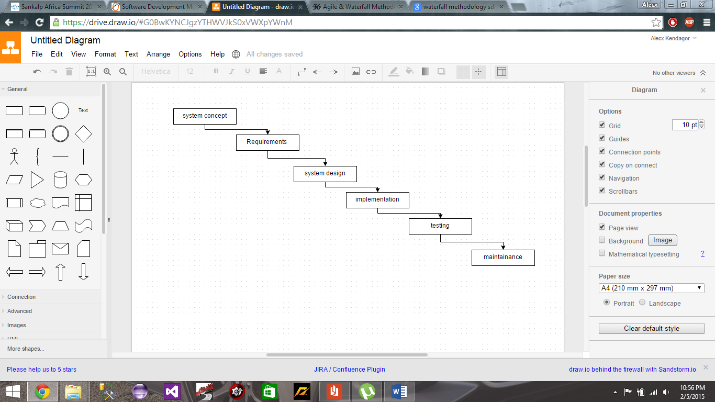

Figure 3.1 waterfall methodology

The main reason for choosing waterfall model is that it stresses on record keeping during development hence, improvement to the system can easily be done in the future. This is important upgrading the system will be simpler. (Base36, 2012)

# 3.2 Analysis

# 3.2.1 Functional requirements

The operation and functionality of this system is very simple. The course administrator will set up a qualification grade and a period within which application can be received. When the student login to the system at the application period he/she will find the application domain open. He/she will be required to enter some information such as which course he/she is applying for and the intake period he/she would like to join. The system then checks from the academics module to check whether the student has qualified, together with other details such as his/her high school grades in math and English. The student then receives his results instantly.

The administrator can be able to view the number of students who have applied in a particular course, and can therefore set an appropriate time for the qualified students to enroll.

# 3.2.2. Non Functional requirements

In order to use this system without any problem one has to be accessible, therefore in order to access this service one has to have a device that can access the internet it can either be a smart phone or a computer. Therefore this means the system is accessible anywhere any time if internet is available.

Since security of any system is crucial, student will be required to have passwords in order to access the system.

# 3.2.3. Narrative

The concerned student will login to the AMS module or whatever platform the proposed system will be placed. On successful login, he/she will then click on a link maybe going by the name ‘exempt courses’ where he/she will fill in a specific set of forms with different fields e.g. which courses has he/she completed, which year was the course completed, where was the course studied, which exempt course is the student applying for, which year/semester would the student like to join the course being applied for etc. there is no need for the student to fill in his/her bio data as this was previously done when previously registering for a course (although a student who did not previously study at Strathmore University will be required to fill this bio data and a special form for filling these details will be provided on request by the student). After the application process, the information will then be submitted to the faculty administrators where evaluation will take place. The student will be notified once the decision has been made and he/she will then be able to check by login into the AMS module once more and going to another provided link e.g. ‘check application submission status’.

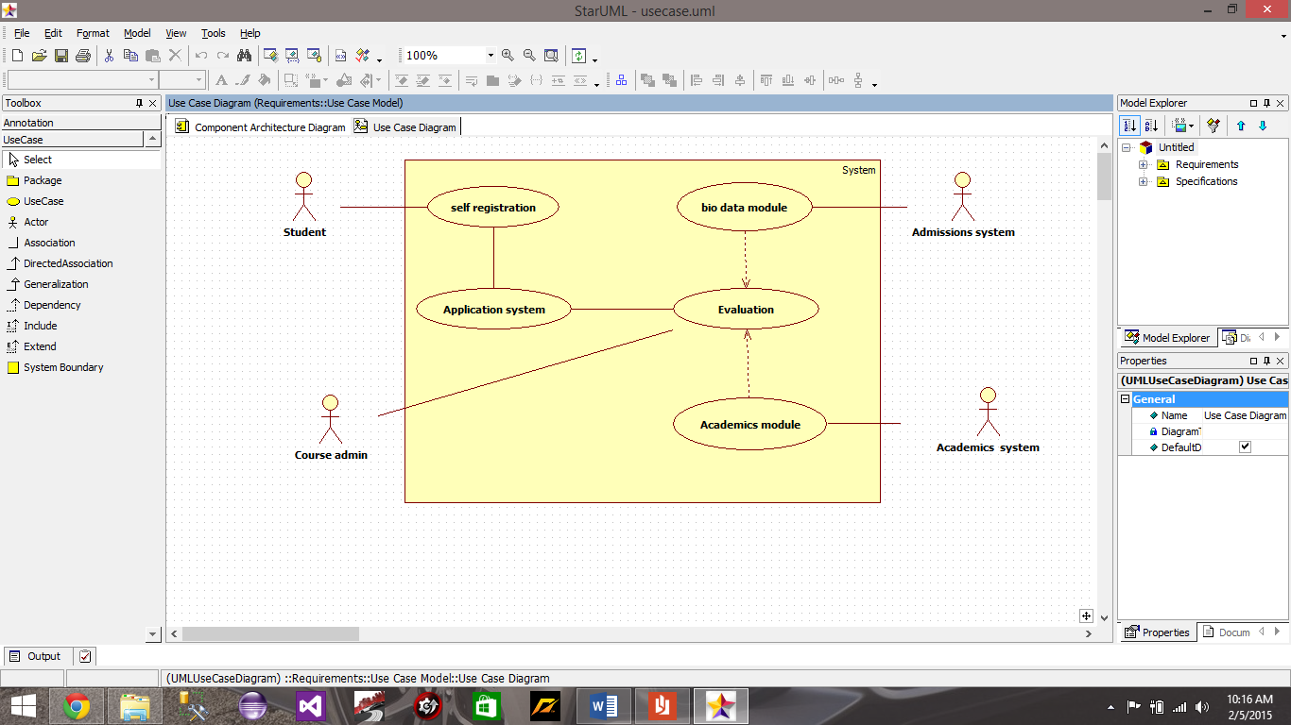

Figure 3.2 use case diagram

# 3.3 Design

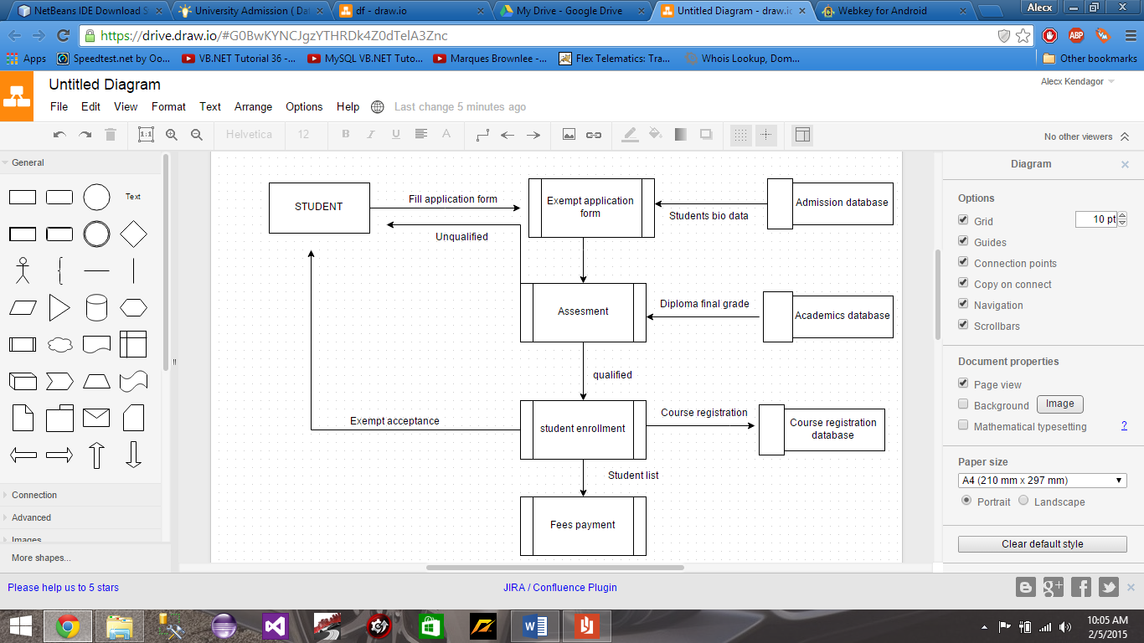

Figure .3 Data Flow Diagram

The data flow diagram above show how a student eligible for exemption in Strathmore does his/her application. The student logs into the system goes to the self-registration portal fills an online application form. The system then confirms the student bio data and moves to the next stage which is analyzing and checking the grades, if the student passes the set grade (credit or distinction) he/she is enrolled. If he/she fails the system notifies the student that he/she has not qualified. Qualified students are enrolled to the applied course and a list of all applicants is generated and viewed by the course administrators.

The proposed system will have four main entities the Admissions, Course admin, Course exempt and Academics all of which are derived in the university database. The reason for four entities, is that there has to be bio data and academic grades for one to apply for exempt courses.

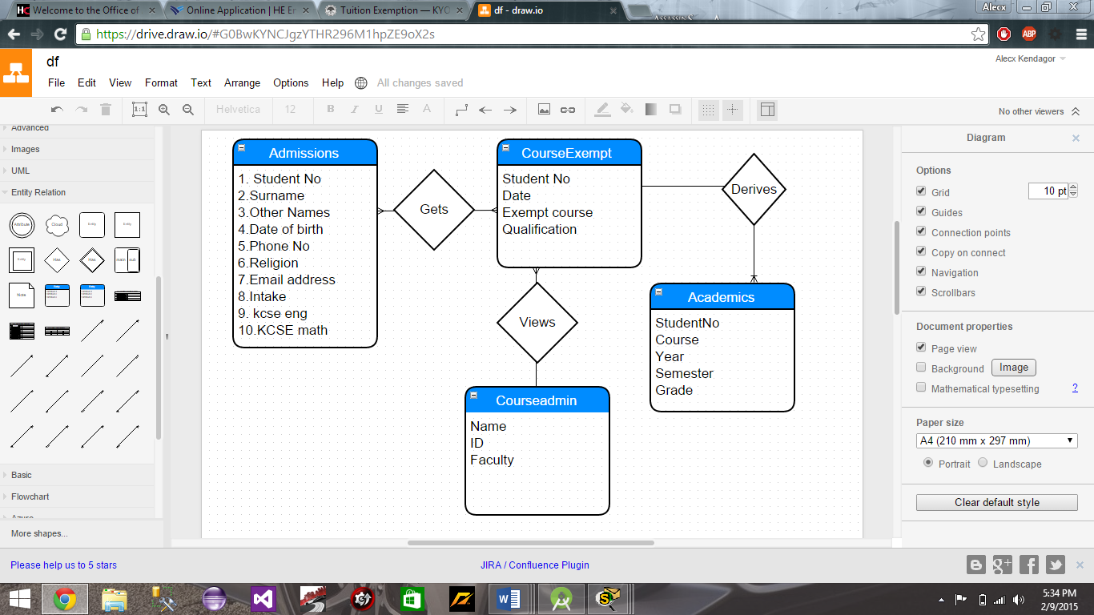

Figure 3.4 Entity Relationship Diagram

# 3.4 System Development Tools And Techniques

This system will require a number of important tools in order to achieve absolute functionality.

Microsoft Visual studio is an integrated development environment for developing application using any of the available programming languages. This software will be very vital since it will help us in developing our application. Visual studio is very user friendly and thus makes development of our project be easier and convenient.

SQL Server 2008 is a database software, it has a variety of services and functions. Since security of any data is vital we choose this software because it has a variety of security options. This server is user friendly and very simple to use since error detection is easily identifiable.

Microsoft Word is a Microsoft office product used in writing documents. It was used in creating this system proposal.

Star UML is a free to use software that is useful in drawing use case diagrams.

Draw.io ([www.draw.io](http://www.draw.io)) is an online tool that was used in creating the entity relationship diagram.

# 3.5 Deliverables

The system will help the institution in a number of ways. It will provide a simple and convenient way for the exempt students to apply for courses and by doing so, will be reducing the amount of paperwork by embracing computerization.

**Appendixes**

# 3.6 References

# References

Base36. (2012, December 13). *Base36 Smart solution*. Retrieved from Base36 Smart solution: http://www.base36.com/2012/12/agile-waterfall-methodologies-a-side-by-side-comparison/

Chapman, J. R. (2004). *Software Development Methedology*. Retrieved from www.hyperthot.com: http://www.hyperthot.com/pm_sdm.htm

College, M. (2015). *Course Exemptions*. Retrieved from www.mohawkcollege.ca: http://www.mohawkcollege.ca/studentservices/recordsregistration/exemptions.html

HeinzCollege. (n.d.). *Course Exemption Information*. Retrieved from http://www.heinz.cmu.edu: http://www.heinz.cmu.edu/academic-resources/course-exemption-information/index.aspx

Leffingwell. (2014, June 11). *Scale Agile Framework*. Retrieved from http://www.scaledagileframework.com: http://www.scaledagileframework.com/nonfunctional-requirements/

University, K. (2014). *Tution Exemption*. Retrieved from http://www.kyoto-u.ac.jp: http://www.kyoto-u.ac.jp/en/education-campus/campus/tuition/tuition_exemption.html

UNIVERSITY, R. (2015). *Ryerson University*. Retrieved from hwww.ryerson.ca: http://www.ryerson.ca/RAMSSsupport/ugrad_grad/academics/transfer_credit_evaluation/